read me

E-commerce part

Programming environment: eclipse 2023-3

Running environment: tomcat 8.5.90, jdk-19.0.2, MySQL 8.0

You can use our website to do the following:
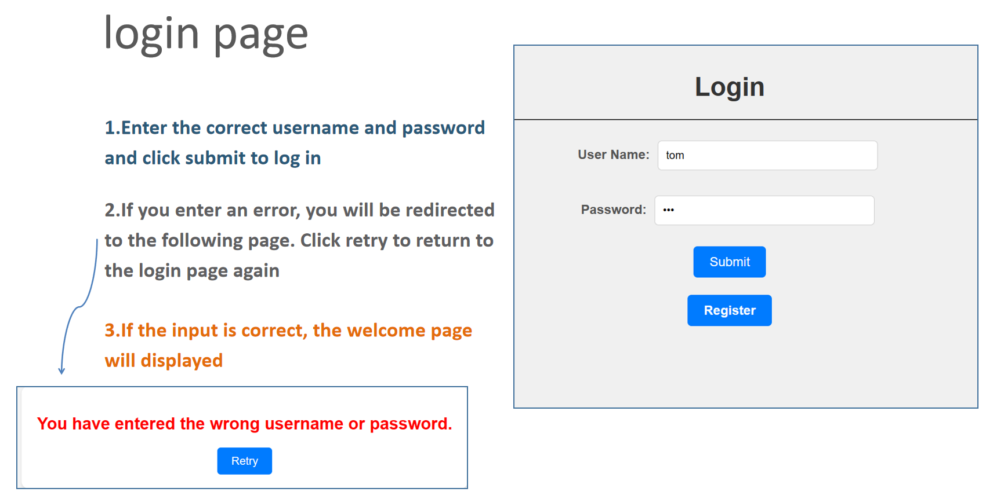
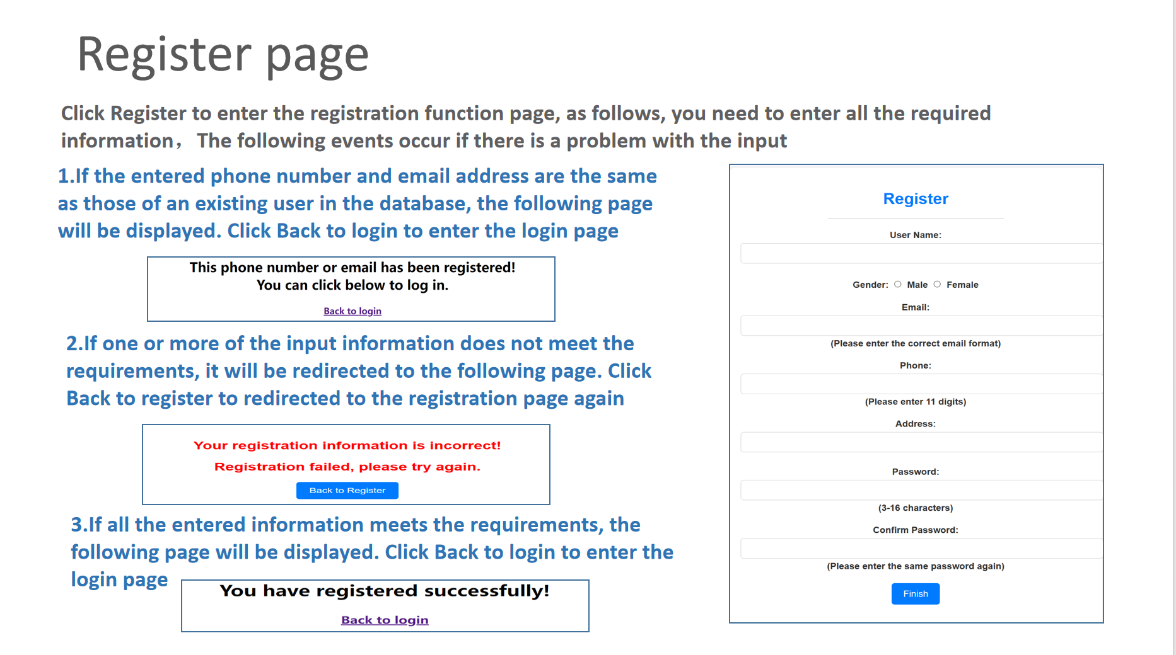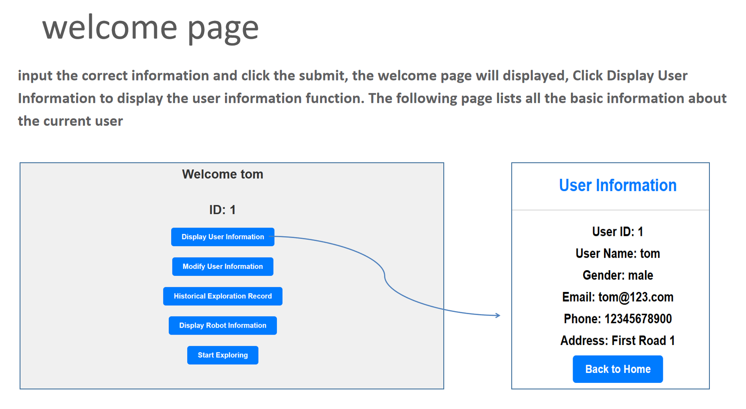
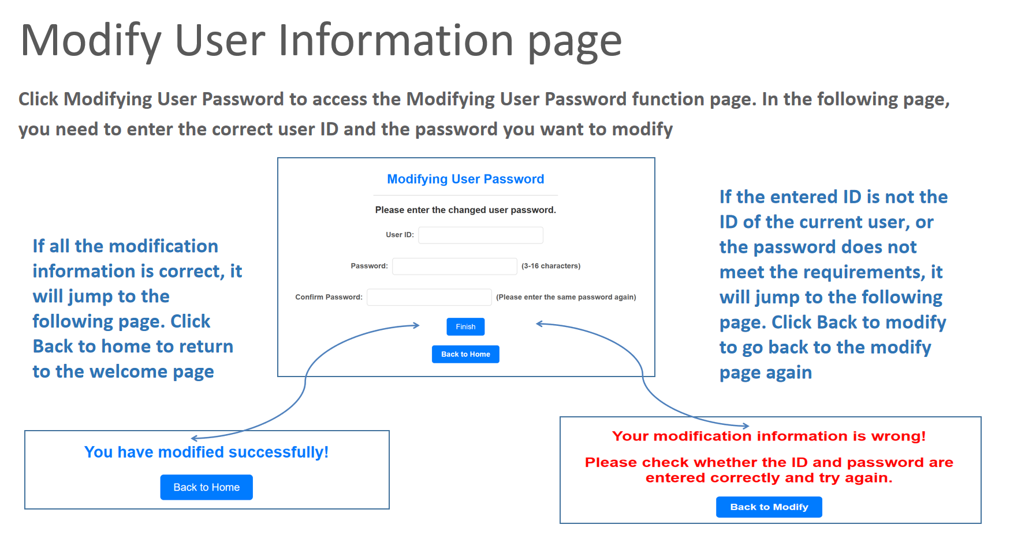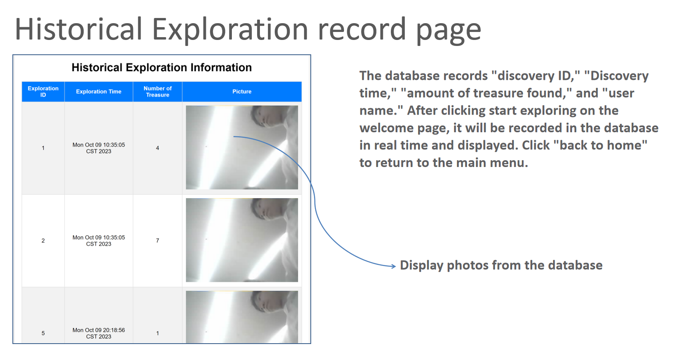
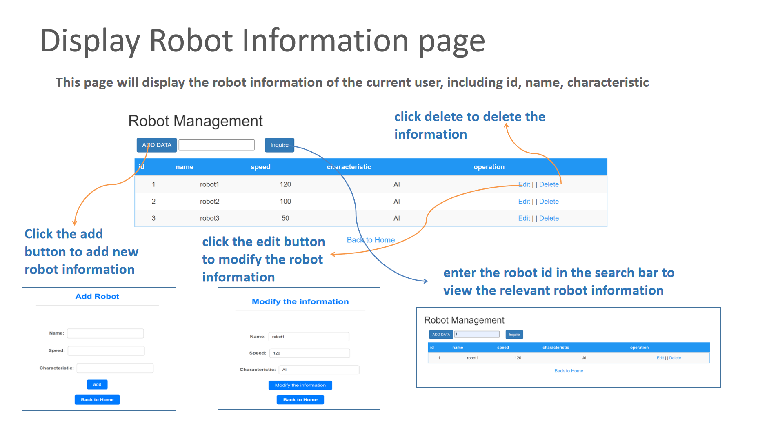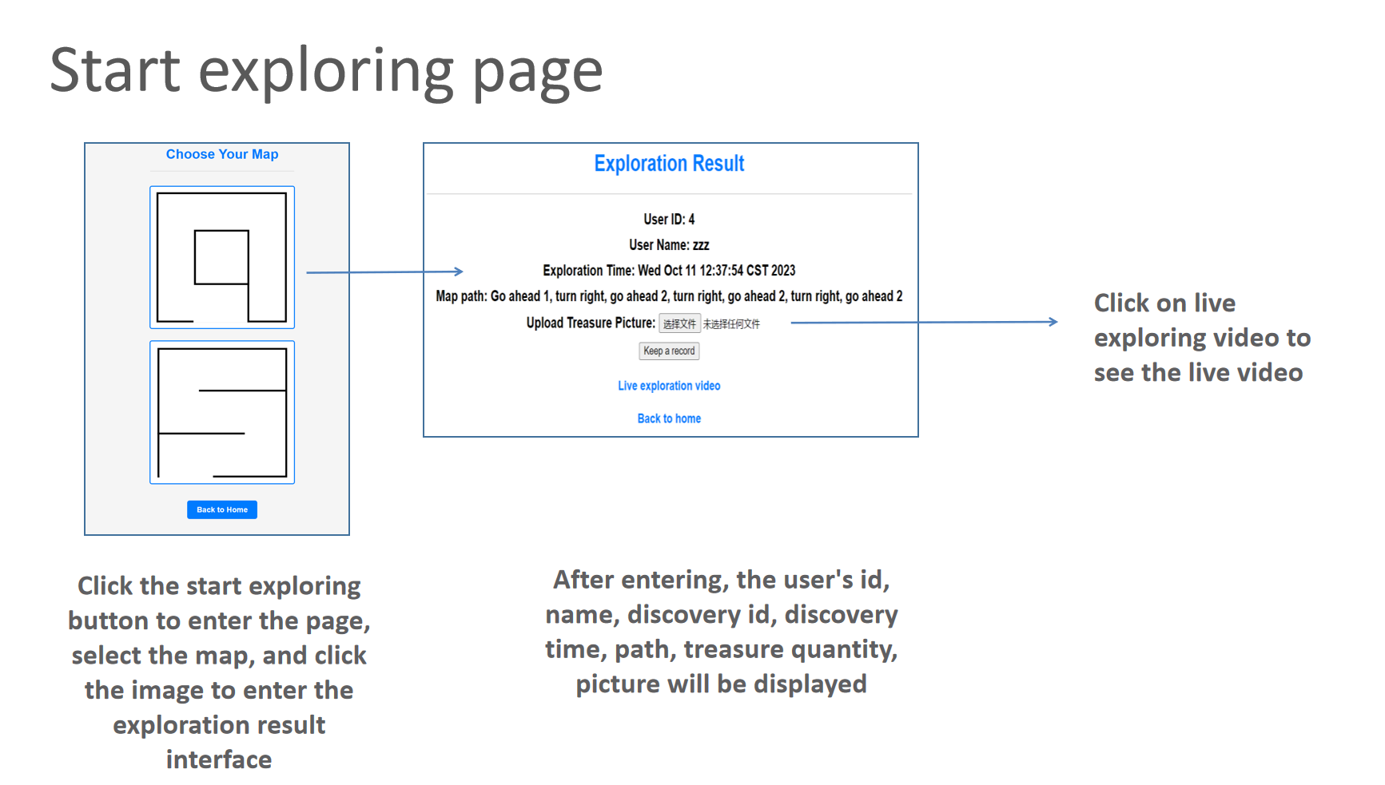
Please note: When you want to upload photos on the Starting Exploration page, you must select photos under the path '.\images\predict4\ ', not photos beyond that.

